Hadoop Assignment
Pawan Bisht
(2018msbda006)

Q1. Write a mapper and reducer for database join using keys?
Sol:
Mapper
#!/usr/bin/python3
import sys
for line in sys.stdin:
print(line)

Reducer
#!/usr/bin/python3
import sys
data1={}
data2={}
result={}
for line in sys.stdin:
l=line.strip().split(',')
if(len(l)==1):
continue
elif(len(l)==2):
data1[l[0]]=l[1]
else:
data2[l[0],l[1]]=l[2]
print("Data1 : \n",data1,"\n","Data2 : \n",data2)
print("For joint data1 join data2 ")
for i in data1.keys():
k=0
for j in data2.keys():
if(i==j[1]):
k=1
break
if(k==1):
result[i,j[0]]=data1[i]+" "+data2[j]
for i in result.keys():
print(i," ",result[i])

Output :
Mapper
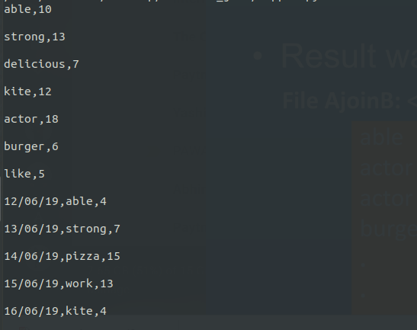

Reducer:
